OVERVIEW:

-THERE ARE ABOUT THOUSANDS OF MALLS IN INDIA AND EVERY YEAR THE PRODUCTION OF MALLS

ACCORDING TO LATEST FACTS, THERE ARE 588 SHOPPING MALLS IN GUJARAT.

INCREASE IN MANY AREAS SO THAT THE PEOPLE LEAVING AROUND THAT REGION CAN EASILY ACCESS THE PRODUCTS OF THE MALL.

-THE IMORTANCE OF MALLS ARE THAT THE PEOPLE CAN GET AS MANY AND ALMOST ALL THE PRODUTS.

-STATISTICAL DATA FOR INCREASING NUMBER OF MALLS FROM 2008:

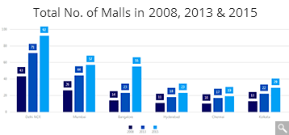

-WE KNOW THAT ALMOST ALL THE PRODUCTS OF OUR DAILY REQUIREMENT ARE AVAILABLE IN THE MALLS.

AS A RESULT, THE NUMBER OF PEOPLE ENTERING THE MALLS FOR SHOPPING HAVE INCREASED EXPONENTIALLY AS WELL AS THE MALLS TOO HAVE INCREASED EXPONENTIALLY.

THIS HAS LEAD TO EXTRA AMOUNT OF CROWD RUSH DURING FESTIVE SEASON AND SALES IN THE MALLS.

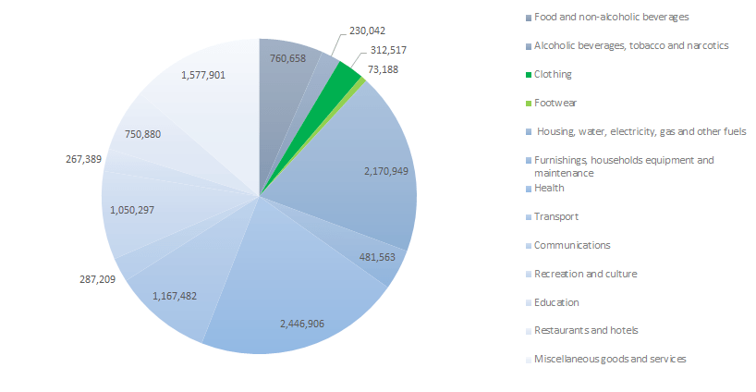

-IN ALMOST ALL THE GENERAL SHOPPING MALLS THERE IS A CASH COUNTER AND DURING HOLIDAYS OR DURING SOME FESTIVAL DAYS THERE ARE LOTS OF PEOPLE AND ONE HAS TO WAIT TILL LONG PERIOD IN PAYING BILLS.

NOW, AS THE RUSH INCREASES THE TIME FOR WHICH THE CUSTOMERS HAVE TO STAND IN THE LINES INCREASES, WHICH IS INAPPROPRIATE AND ALSO NOT SO VERY MUCH ACCEPTED BY CUSTOMERS TOO.

-SO, WE ARE TRYING TO DEVELOP A SYSTEM IN WHICH PEOPLE NO LONGER HAVE TO WAIT IN SUCH KIND OF LONG QUEUES IN SHOPPING MALLS.

-WE AIM AT DEVELOPING THE EFFICIENT AND TIME REDUCING SYSTEM THAT TAKES LESS TIME OF BILLING FOR THE PEOPLE.

METHODOLOGY

IN ORDER TO DEVELOP A SOLUTION FOR THE PROBLEM, THE MAIN PROBLEM WHERE THE TIME OF THE CUSTOMERS IS WASTED IS STANDING IN THE LINES WHEN AN EMPLOYEE OF THE MALL IS SCANNING THE PRODUCTS OF A CUSTOMER AHEAD IN THE LINE FOR BUYING OF THE PRODUCTS THEY SELECTED.

NOW WHY WOULD ONE CUSTOMER HAVE TO WAIT IN THE LINE WHEN OTHERS’ PRODUCTS AE GETTING SCANNED.

BUT IT’S NOT FEASIBLE TO HAVE COUNTERS FOR EVERY CUSTOMER IN THE MALL.

SO, COMING TO THE SOLUTION, WE WILL DEVELOP A MOBILE APP WHICH WILL BE USED BY THE CUSTOMERS TO SCAN THE PRODUCTS THEMSELVES AT THE TIME THEY SELECT THEM.

THIS WILL REDUCE A SIGNIFICANT AMOUNT OF TIME OF THE CUSTOMERS IN THE QUEUE.

IN THE QUEUE FOR CHECKOUT THE EMPLOYEE WILL ONLY CHECK THE PRODUCTS IN THE CUSTOMER’S APP AND THE PRODUCTS HE/SHE IS CARRYING.

AFTER THAT THEY WILL TAKE THE PAYMENT FROM THE CUSTOMER AND THEY WILL CHECKOUT OF THE MALL.

TOOLS AND TECHNIQUIES TO BE USED:-

--AS WE NEED TO STORE HUGE AMOUNT OF DATA (DATA RELATED TO ALL THE PRODUCTS IN A PARTICULAR MALL), WE WILL HEAR USE A DATABASE MANAGEMENT SYSTEM THAT IS CAPABLE OF STORING LARGE COMPLEX DATA(AS IN FUTURE OUR DATA’S COMLEXITY WILL INCREASE).

--WE ARE DESIGING THE EFFECTIVE AND EFFICIENT DATA BASE SYSTEM THAT WILL MANAGE BACKEND AS WELL AS THE FRONTEND.

--THE PART REGARDING THE FRONTEND WILL BE DONE IN AN ANDROID APPLICATION.

--IN DATABASE WE CAN SCAN THE PRODUCT WHENEVER THE PARTICULAR PRODUCT IS KEPT IN THE MALL.

--NOW THAT IF A USER WANTS TO PURCHASE A DAILY NESSECITY PRODUCT THEN HE/SHE WILL SCAN THE CODE OF A PARTIULAR PRODUCT SO THAT THE DETAILS REGARDING THE PRODUCT WILL APPEAR IN OUR APPLICATION AND HE/SHE WILL SCAN FOR AS MANY PRODUCTS AS THE COSTUMER WANTS TO BUY.

--NOW AS PER THE BILLING PART THE CHECKOUT OPTION WILL CHECK ALL THE DETAILS (INCLUDING PRICE) AT THE CASHCOUNTER AS THE CUSTOMER PAYS FOR THE PRODUCTS OUR DATABASE WILL BE UPDATED (IF CUSTOMER TAKES X NO. OF PRODUCTS THE DEATILS OF THESE PRODUCTS ARE DEDUCTED FROM OUR DATABASE).

--SO, AT A PARTICULAR TIME PERIOD, WE ARE USING BOTH THE FRONTEND AND BACKEND PART.

POSSIBLE OUTCOME:

--BASICALLY, WITH THE HELP OF THESE SYSTEM WE ARE ABLE TO REDUCE TIME TAKEN FOR THE BILLING PROCESS.ALSO USER DO NOT HAVE TO STAND IN A QUEUE FOR PAYING THE BILLS.

--THIS BENEFIT WILL BE AVAILABLE TO ALL THE MALLS OPERATING OUR WELL-DEFINED DATABASE.

--

CHALLENGES/RISKS IMPLEMENTING THE PROTOTYPE:

--MAJOR DRAWBACK OF OUR DATABASE SYSTEM IS TO HANDLE VERY COMPLEX AND BIG MAOUNT OF DATA. OUR DATABASE SYSTEM SHOULD BE ABLE TO HANDLE LARGE AMOUT OF DATA.ANY KIND OF MALFUNCTION WILL LEAD TO COMPLETE DATA LOSS.SO SECURITY OF DATA IS ONE OF THE MEASURE.

--OUR DATABASE SHOULD BE MADE FOR A PARTICUAR MALL ONLY SO THAT DATA WILL BE LIMITED AND WE CAN EASILY ABLE TO HANDEL THE DATA.

--TALKING ABOUT ONE PARTICULAR MALL, THE MALL WHICH ARE USING THIS SYSTEM SHOULD USE THIS SYSTEM FOR ALL THE PRODUCTS IN THE MALL AND NOT FOR SOME PARTICULAR PRODUCTS.

--ANOTHER MAJOR CONSTRAINT IS TO HANDEL THE COMPLEXITY OF THE DATA IN THE DATABASE IF WE ARE ABLE TO HANDLE THE LARGE AMOUNT OF DATA THEN IT IS MORE EFFICIENT TO USE OUR SYSTEM.